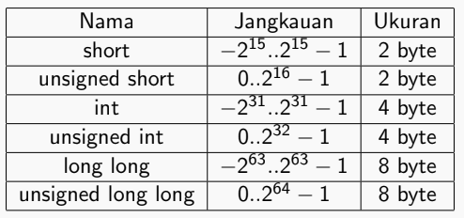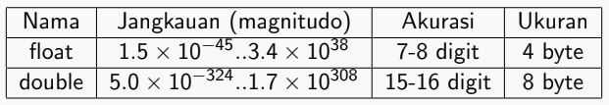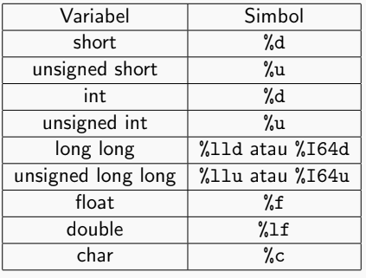



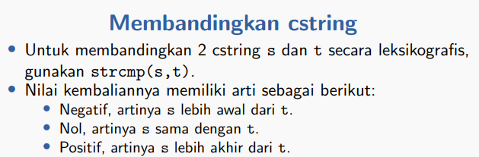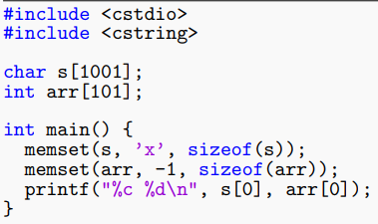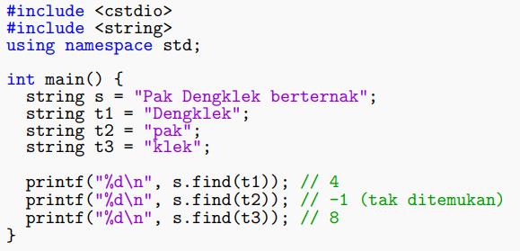

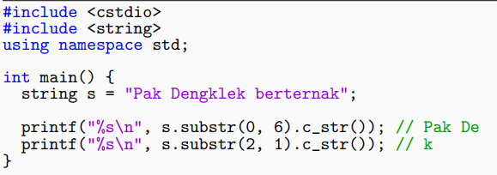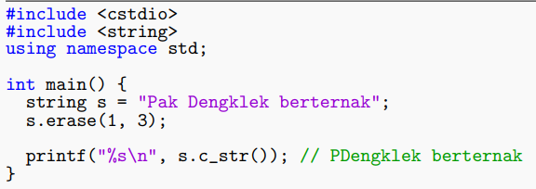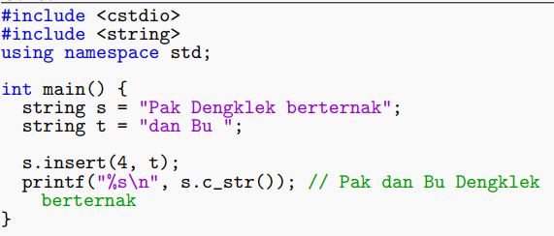

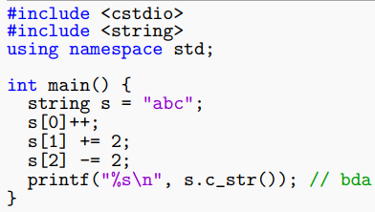

Compile :

“g++ file.java -o output.exe” atau “g++ file.java”

“./output.exe” atau “a.exe”

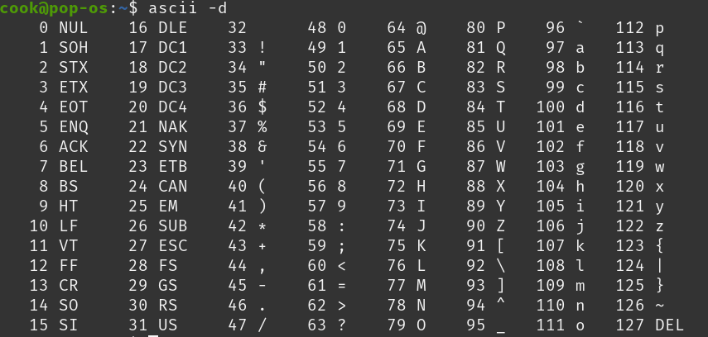

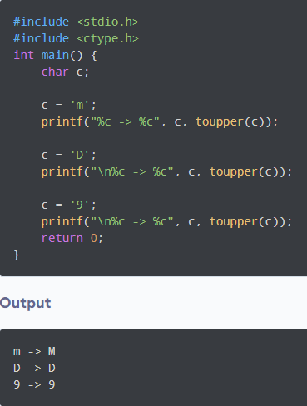

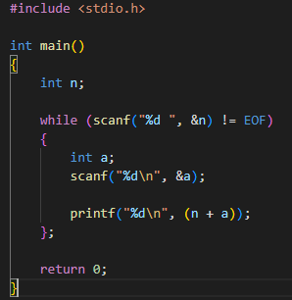

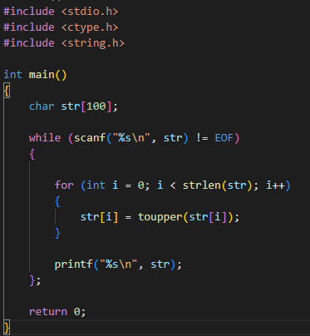

// toupper -> toUpperCase

Cara lain:

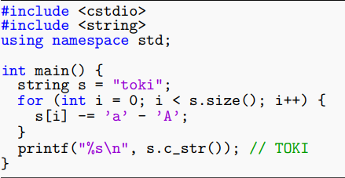





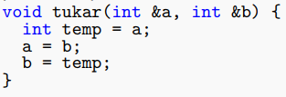

#include <vector>

using namespace std;

vector<type> arr; // type bisa int, String, dll

arr.push_back(nameString); // input

sort(arr.begin(), arr.end()); // sorting vector

arr.size(); // ambil length arr

arr[i] // access

#include <algorithm>

Using namespace std;

sort(arr, arr + size, greater<int>());

reverse(arr, arr + size);

min(a, b);

max(a, b);

int myints[]={10,20,30,40,50,60,70};

vector<int> myvector (7);

copy(myints, myints+7, myvector.begin());